Linking Components in a Repeat or Ring

Please refer to the Example\Using Variables\RINGVARS, this document only deals with the highlights of using variables to interconnect the components. The picture below shows the end result.

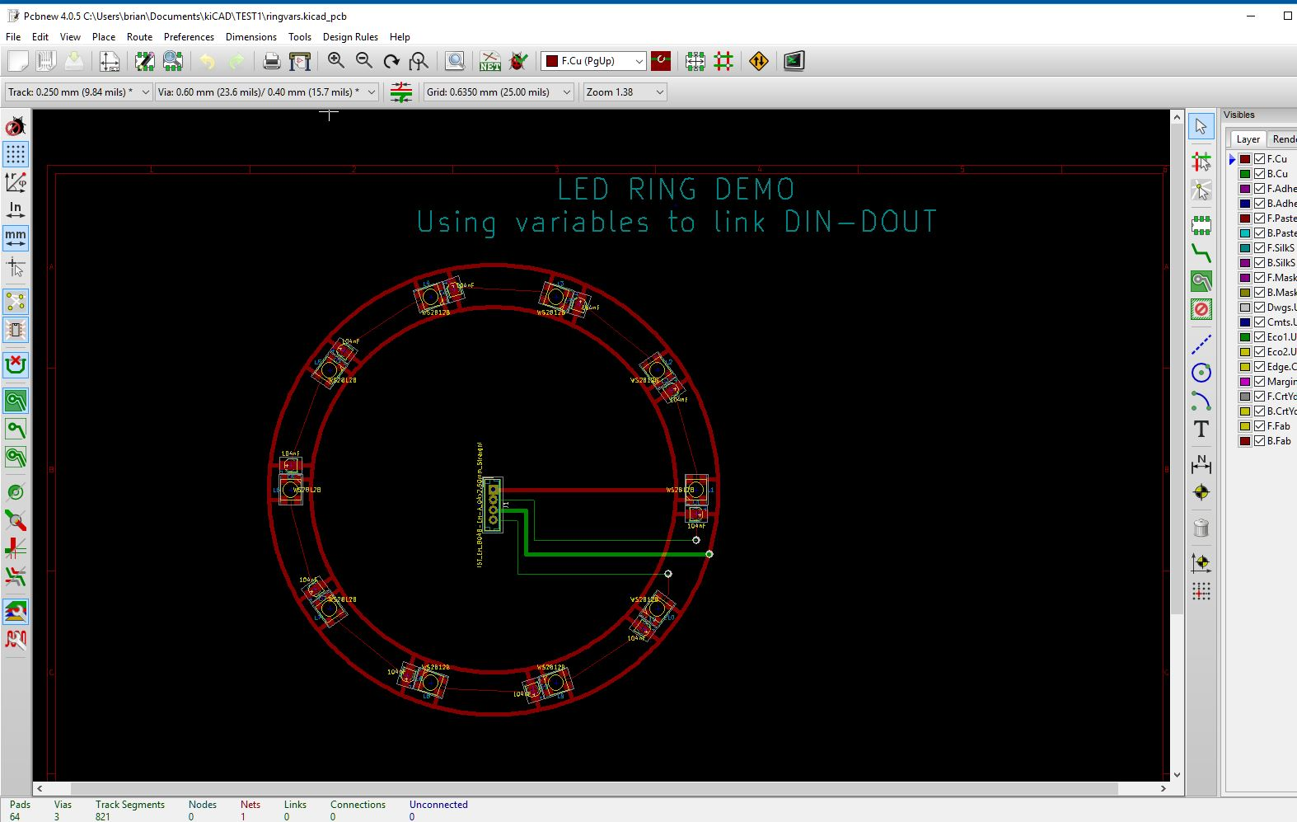

Linking components in a RING or REPEAT requires the use of two commands:-

**SAVEXY,varName,xx,yy**

This saves the transformed coordinates of xx,yy in a global list which makes it available to, for example, the next GROUP within a REPEAT or RING. It works by adding _X and _Y to the varName so when you use the command SAVEXY,DIN,3.2,0 the program actually creates two variables called DIN_X and DIN_Y which you can then use.

Note: if you have a local or global variable called DIN_X (or DIN_Y) they will be masked by using this command. The advice is – don’t declare variables with the names DIN_X etc.

The SAVEXY variable is not deleted when a RING ,GROUP or REPEAT terminates. This allows other global commands to know what the DIN_X and DIN_Y values were when a RING, GROUP or REPEAT ended. This is useful for continuing track linking outside the loop/group.

**SAVEONCEXY,varName,xx,yy**

Similar to SAVEXY but the values of varName_X and varName_Y are not overwritten in a loop. This then allows you to know where something was at the start of a RING, GROUP or REPEAT so that, for example, tracks from outside the RING, GROUP or REPEAT can be connected to the start point.

Step 1 – create the component as a group and add any group tracks you need.

L1 is my WS2812B LED so pin 1 will go to +5v. Pin 3 is GND. Pin 2 is DOUT and PIN3 is DIN. I have added signal tracks for the data signal and brought them out to easily accessible locations so that I can link to the ends of the traces without worrying about the internal routing.

C1 is a capacitor to filter the effects of LED switching noise on the supply line so pin 1 goes to 5V and pin 2 goes to GND.

I have hidden most layers to make this clearer:-

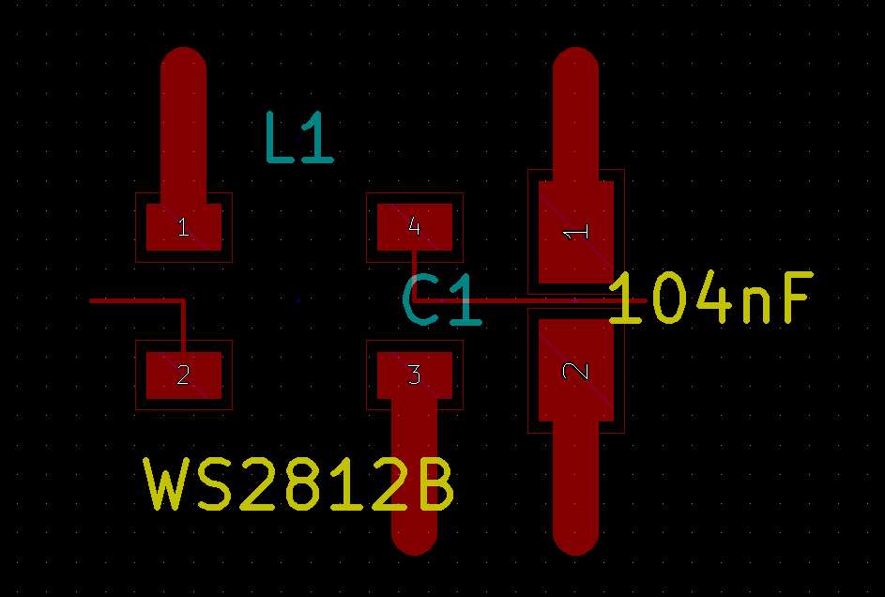

The LEDs will be placed anti-clockwise by a RING command so I need to connect the DOUT of the previous LED to the DIN of the next led. The code below defines the group :-

|  |
| --- |
| # define some variables to use  # these are global so they are visible within the ring loop  SETG,SignalWidth,0.1  SETG,PowerWidth,1  SETG,LayerF,F.Cu  SETG,LayerB,B.Cu  SETG,Net,0  SETG,centreX,100  SETG,centreY,100  # LED_CAP group DEFGROUP,LED_CAP WS2812B,L,0,0,0,LayerF CAP,C,-90,6,0,LayerF   # LED pin 2 DOUT is at **-4.5,0** SEGMENT,LINE,-2.5,-2,-2.5,0,SignalWidth,LayerF,Net SEGMENT,LINE,-2.5,0,**-4.5,0**,SignalWidth,LayerF,Net  # LED pin 4 DIN is at **7.5,0** SEGMENT,LINE,2.5,2,2.5,0,SignalWidth,LayerF,Net SEGMENT,LINE,2.5,0,**7.5,0**,SignalWidth,LayerF,Net  # link this DIN to previous LED DOUT # this will fail **the first time** because DIN_X and DIN_Y have not # yet been defined and the segment will not be drawn # Some warnings will be sent to the console but these can be ignored  SEGMENT,LINE,DOUT_X,DOUT_Y,**7.5,0**,SignalWidth,LayerF,Net  # remember this DOUT_X and DOUT_Y for the next LED’s DIN_X and DIN_Y SAVEXY,DOUT,**-4.5,0**  # LED pin 1 5V # SEGMENT,LINE,-2.5,2,-2.5,5,PowerWidth,LayerF,Net  # LED pin 3 GND SEGMENT,LINE,2.5,-2,2.5,-5,PowerWidth,LayerF,Net # capacitor 5V SEGMENT,LINE,6,2,6,5,PowerWidth,LayerF,Net  # capacitor GND SEGMENT,LINE,6,-2,6,-5,PowerWidth,LayerF,Net ENDGROUP |

That’s it. This group’s signal track will link to the next group. Now we use the LED_CAP group in a ring:-

|  |
| --- |
| # define a ring using just the LED_CAP group  DEFRING,RING1  GROUP,LED_CAP,0,0,0  ENDRING |

Now we created the ring of components:-

|  |
| --- |
| RING,RING1,centreX,centreY,50,-90,0,10,36 |

After that we need to connect to the LED DIN/DOUT using the SAVEXY variables created in the ring.

|  |
| --- |
| # lay down vertical tracks to the DIN and DOUT signals of the ring  # to connect to some VIAs  SEGMENT,LINE,DIN_X,DIN_Y,RINGIN_X,RINGIN_Y,SignalWidth,LayerF,Net  SEGMENT,LINE,DOUT_X,DOUT_Y,RINGOUT_X,RINGOUT_Y,SignalWidth,LayerF,Net |

That’s the important bit. The remainder of the RINGVARS demo concerns itself with inserting a 4 pin JST connector, adding some VIAs and laying down tracks from the JST to the relevant points on the ring.